Roman Catholic Diocese of Brooklyn and Queens
Committee on Scouting

Welcomes the arrival of the
International Peace Light From Bethlehem to the USA
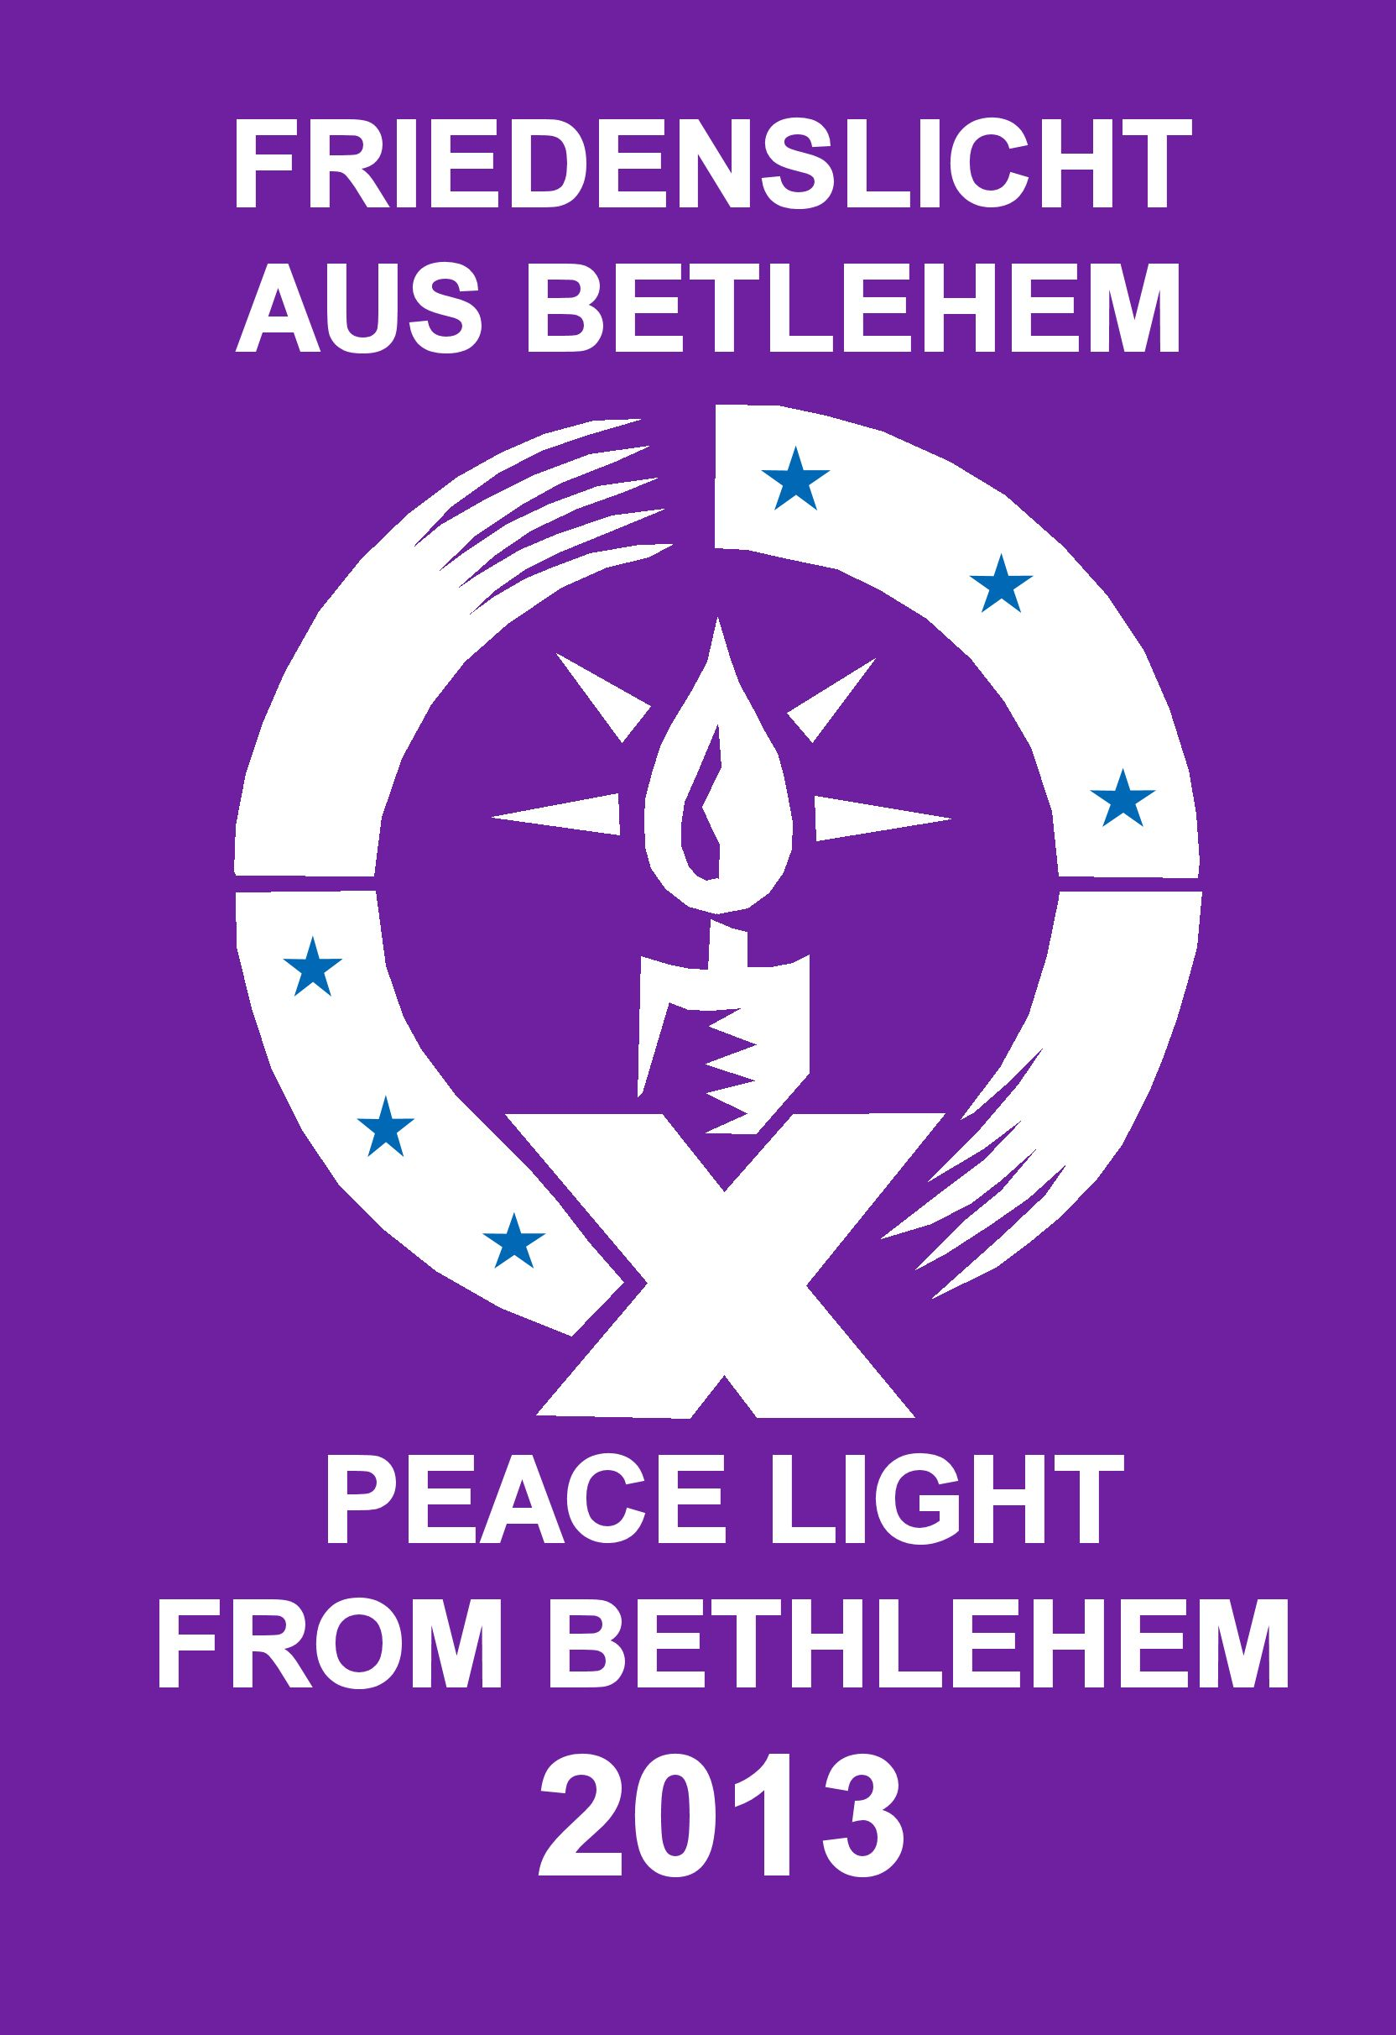

Ceremony of Reception
Wednesday, December 4, 2013
2:30 PM
Our Lady of the Skies Catholic Chapel
JFK International Airport

PROGRAM

Gathering of Participants

Distribution of Programs

Terminal Four Short Term Parking Ticket Validation by Chapel Office Secretary
(Small donation to the Chapel is encouraged in exchange for the validation of your short term parking ticket)

Performance by Xaverian H.S. Chamber Orchestra under direction of Joseph Loposky, Music Director

Lite Refreshments

Ceremony will commence after the arrival of the Peace Light flame on Austrian/ Tyrolean Airlines/ flight from Vienna, Austria

Welcome
By Rev. Fr. Chris Piasta, Chaplain JFK International Airport

Introduction of Distinguished Guests
By Henry Zalak, CCOSBQ Chairman
Most Rev. Auxiliary Bishop Paul Sanchez
Scout Chaplains and Rev. Members of Clergy
Rev. Peter Colapietro, Archdiocese of NY
Members of the Diocese of Brooklyn Catholic Committee on Scouting
Boy Scouts of America / Girl Scouts of America Representatives
Representatives of Austrian/ Tyrolean Airlines
Representatives of International Scouting Organizations, PLAST, Ukrainian, Polish, Lithuanian
WEB TV & Tablet
Port Authority of NY/ NJ
Port Authority of NY/NJ Police Department
Department of Homeland Security, TSA and US Customs

Opening Prayer
Rev. Fr. Thomas Vassalotti, Chaplain
Catholic Committee on Scouting - Diocese of Brooklyn/ Queens

Presentation of the Pelican Award to Fr. Piasta

Opening Hymn – Prayer of St. Francis

Messages from World Peace Light Organizers

Distribution of the Peace Light Flame
[All present will be given a candle by the Girl Scouts to ignite with the Peace light Flame. Those present with lanterns will be assisted lighting lanterns by CCOS members.]

Opportunity for Photographs

All say:
“We gladly receive this light as a sign of our willingness
to be channels of peace, by our words and actions”.
[Candles “infused with the Peace Light flame” are extinguished, and taken by participants to be given to others or sent with a message over distances where a live Peace light flame can not
be safely transported, such as to Troops members serving in Afghanistan, rescue workers in the Philippines, etc.]

Reading from Isaiah
Scout

The people who walked in darkness have seen a great light. Those who dwelt in a land of deep darkness, on them has light shined. Thou hast multiplied the Nation; thou has increased its joy. They rejoice before thee as with joy at the harvest, as men when they divide the spoil. For unto us a child is born, to us a son is given, and the government will be upon his shoulder, and his name will be called “Wonderful Counselor, Mighty God, Everlasting Father, and Prince of Peace”.

Of the increase of his government and peace there will be no end. Upon the throne of David, and over this kingdom, to establish it, and to uphold it with justice and with righteousness from this time forth and for evermore. The zeal of the Lord of hosts will do this.

REFLECTIONS ON THE READING AND PEACELIGHT
Aux. Bishop Paul Robert Sanchez and Chaplains

Hymn
Let There Be Peace on Earth
(Leader of Song)

Peace Messages and Prayers
Offered by Participants

Peace Light Hymn

We Sing, (to the tune Edelweiss), the a Hymn written by the Austrian Scouts and Guides and as a thank you salute to them, and our scouting friends in the Transatlantic Council who will represent the BSA and GSA at the 2013 Peace Light distribution ceremony in Vienna, Austria

Come, O Lord, be with us
Fill us with joy and thanksgiving
May our hearts flow with peace
Come with Your love, surround us.
Friendship and peace, may they bloom and grow,
Bloom and grow forever.
Bless us now, bless our friends.
Bless all mankind forever

Father God up above
All your blessings surround us
love and care, everywhere
In the world all around us.
Grant that our services may be of use
Bless the Peace Light endeavor
Father God, up above
Bless us now and forever

LORDS PRAYER

Closing Prayer

May the peace of God and the love of mankind guide us throughout this special day and let out light so shine that men will see our good works and glorify God.

We are met in the spirit of thanksgiving and joy, for the Peace Light from Bethlehem is in our presence.

May the peace symbolized by this Light touch each person who carries it and each who receive it. It is through this sharing of the light of Christ that we pray for the peace of God be spread to all, this Christmas time and always.

The Grace
(Said by All)

The Grace of One we call Lord
The Love of God
The Fellowship of his kindly spirit
Be with us all evermore

[Time for Group Photographs / Interviews by Media, Exchange of Distribution Plans, Signing of Cards, Guest Log, Hugs, etc.]

History of the Peace Light

The Peace Light, symbolic of the Light of Christ especially evident at Christmas, is meant to promote peace, harmony and unity among the people of the world regardless of race, ethnicity or creed. For several decades, the International Scouting movement, Boy and Girl Scouts, have actively promoted global peace and harmony through the distribution of the Peace Light.

Now in its 28th year, the Peace Light from Bethlehem campaign was originally organized by the Austrian Broadcasting Company - ORF (Linz) - and was part of a large charitable relief mission - Light into Darkness, for children in need in Austria and abroad. Since 1986, there has been a great deal of cooperation between Scouts and Guides in many countries which has allowed the light to travel throughout Europe, such that the light is passed on 30 European Countries and for the past decade on to America, Canada and Mexico.

Each year, a child from Upper Austria travels as a pilgrim to obtain the light from the grotto in Bethlehem where Jesus was born. The light is then flown to Austria from where it is distributed at a Service of Dedication to delegations from across Europe who take it back, with a message of Peace, to their own countries for use at ecumenical services throughout the Continent. Scouts and Guides then take the light on to other churches, hospitals, old people homes, prisons, and places of public, cultural and political importance - to anybody that appreciates the significance of the “gift”.

In past years the light has been presented to Pope John Paul II and Pope Benedict XVI, Mikhail Gorbatshow, former King Hussain of Jordan, EU President Romano Prodi and other member of the European parliament, the UN Troops in Kosovo, US Military Chaplains, the Rector of St. Patrick’s Cathedral in NY, and to the families who lost children at Sandy Hook, CT. At St. Paul’s Chapel, on Broadway, in NYC a Peace Light Lantern and flame is displayed on the Church Altar, presented as a tribute to the Church’s role in providing spiritual support and a place for quiet reflection and peace for Ground Zero rescue and recovery workers following the tragic events of 9/11.

“The Light of Friendship & Peace” was first introduced to the United States in the year 2000. It was flown over from Oslo, Norway with a brief stopover in London, England before landing in Bartlesville, Oklahoma the headquarters of Phillips Petroleum Co., the sponsors of the flight. The light quickly spread to six states in the heartland of America.

The Catholic Committee on Scouting of the Diocese of Brooklyn and Queens, and the Greater NY Councils BSA International Representative again have the privilege of welcoming the Light to the United States, at the request of Austrian Scouting and in conjunction with the International Division of the Boy Scouts of America, following its long journey from the Grotto of the Nativity in the Town of Bethlehem, City of Jerusalem, in Israel, to Vienna, Austria and finally safely across the Atlantic Ocean to NYC.

Special thanks to our friends in Austrian Scouting and the professionals of Austrian/ Tyrolean Airlines for making this cross Atlantic Ocean Peace light Distribution possible. Following the reception at Our Lady of the Skies Chapel the Peace Light will be distributed by hundreds of Girl and Boy Scouts at various locations nationwide in order to promote peace and harmony. If there is to be World Peace it must begin at a personal level. Please note that while Scouts send the peace Light and receive it for the people of the United States, the symbol, when presented as a gift, can benefit and uplift people from all walks of life, ages, religions, cultures, etc. Our Committee’s goal is to see the Light, distributed to as many possible groups, organizations, and individuals as possible during Advent, Christmas and by New Year’s Day 2014.

Many Churches use the Peacelight in Advent worship services, parish tree lighting events, and many even maintain the Peacelight year round using the flame to ignite their Sanctuary Lights, Baptismal Candles, Votive Lamps, School and Rectory hot water heater and stove pilot lights. The Plast, Lithuanian and Ukrainian Scouting Groups in the USA and Canada have also widely supported the Peace Light distribution program. This year, these group’s Peace Light distributions will be open to the Polish Scouting Association’s members in the USA.

As residents of the World Capital City of New York we have a special interest in seeing that the Peace Light’s message reaches the families of U.S. Military and Government personnel worldwide, especially those who are currently deployed and will be far away from their families during the Christmas and the New Year Holidays. In the past volunteers, the Peace Light has been presented to Military Chaplains, representing soldiers from Fort Hamilton, Brooklyn, Fort Bragg NC, the Pentagon and other duty stations. The Transatlantic Council of the BSA annually distributes the Peace Light widely on the European Continent to American families and military members working abroad.

Joe Reding of Boy Scout Troop 113, in Bayport Minnesota, continues an amazing Peace project this holiday season, by maintaining a Peace Light distribution and tracking tool on their Web Site. “www.peacelight.org”. He tracks and maps the movements of Peace Light by zip codes across the USA, Canada, and Mexico. Scouters Roger Knutson and Joe Reding personally logged more than 10,000 miles traveling roundtrip to NYC to gather the flame at JFK in 2010 & 2011. In 2012 Joe Reding also developed a “Facebook – North America” web site. You are welcome to join this site and share Peace Light distribution plans and news with other members.

Worldwide, communities seeking international friendship and peace are a special concern of all Boy & Girl Scouts here and abroad. According to the ideals of Scouting, Scouts pledge to encourage everyone, all nations and peoples, through personal contacts to actively create Peace and fear-free living in their environment by being tolerant towards different ethnic, cultural or religious groups.

You are invited to send information about your 2013 Peace Light Distributions including photos and links to published articles about your Peace Light events to Peacelight@peacelight.org and pdstanton@aol.com You will find links to the UK and other World Scouting Peace Light contacts at these websites
www.bsainternationalpeacelightusa.org http://www.peacelight.org.uk/

Thanks

To Fr. Chris and Alice for hosting today’s event at JFK’s beautiful Our Lady of the Sky’s Chapel

To Aux. Bishop Paul Robert Sanchez and Fr. Tom Vassolotti for serving as the emcee and lead Celebrants for our 2013 Peace Light Event

To Henry Zalak, Chairman and the Members of the Diocese of Brooklyn Committee on Scouting for ongoing planning and coordination of the Annual Peace Light Arrival Event

To NYS Martin Golden for the gift of Peace Light 2013 - USA Arrival Emblems

To Mr. Joseph Loposky and the members of the Xaverian H.S
Chamber Orchestra for your gift of joyful holiday music

To the Girl Scouts and Leaders of St. Mel’s Church, Flushing, NY
For the gift of candles, so everyone can leave with a “Peace Light” infused candle to share with others

To Long and Delosa Construction Group for the contribution of today’s programs

To all “Messengers of Peace” who have traveled from near and far to be here today to receive the Peace Light flame originating at the Grotto of the Nativity, Town of Bethlehem, and City of Jerusalem, Israel

Best wishes from Most Rev. Nicholas Di Marzio, Bishop of the Diocese of Brooklyn, to all for a safe and joyful Advent and Peace Light sharing experience.

