2015 INTERNATIONAL PEACE LIGHT

This flame originated in the City of Bethlehem in the country of Israel. We bring you this light in the spirit of the one who was born there over 2,000 years ago, Jesus Christ, the one that the Bible calls, the Light of the World and the Prince of Peace.

The prophet Isaiah, long ago, spoke these words,

The people who walked in darkness have seen a great light; those who lived in a land of deep darkness – on them light has shined. – Isaiah 9:2

This light gives us hope, that even though there is much darkness in the World, we can still see signs of a loving and peaceful community. We can still be people living together in harmony, and working together for peace and justice.

Please receive the Peace Light as a visible reminder of the mission we share. As believing people, our mission is to keep the hope of peace alive in our World, our communities, and our homes.

The Path of the 2015 Peace Light
This flame was first collected by nine-year-old Telen Ihab Msleh of Bethlehem, from the Grotto of the Nativity in Bethlehem, Israel. Austrian Air then successfully flew the Peace Light to Austria, and then on to New York City. It was then distributed at a brief ceremony at JFK Airport on November 28th. From there the Peace Light flame has travelled across our United States headed to Bayport, Minnesota. It will be shared along the way travelling north into Canada, west to the western United States and south all the way to Mexico. The flame is passed during its journey from scouter to scouter each doing their part to share its message of Peace for all.

This light was gathered from Queen of All Saints Catholic Church, in Michigan City. It was then delivered to the Danville United Methodist Church, in Danville, Indiana, and then south to churches in Edwardsville and New Albany, Indiana. You are encouraged to share the Light with others as a reminder of what is most important during this season. That we share the Peace with one another, around the World.

Prayer of the Peace Light
Dear Heavenly Father, we thank you that your light shines in the darkness and the darkness cannot overcome it. Make us ambassadors of your peace in all that we do, think, and say. Bless the flame we carry and share with others. May it burn brightly in the lives of those who need to hear a word of hope. May it give courage and confidence to all those who face the darkness. Thank you God for your light. Amen.

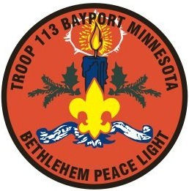

More information is available on-line at www.PeaceLight.org.

