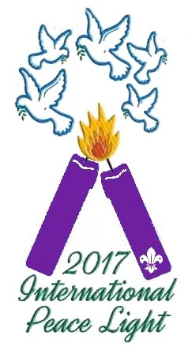  This flame originated in the grotto of Jesus’ birth in Bethlehem.  Please let us know who has received it. Post a message on the Facebook group  Peace Light - North America  More information available at www.peacelight.org | This flame originated in the grotto of Jesus’ birth in Bethlehem.  Please let us know who has received it. Post a message on the Facebook group  Peace Light - North America  More information available at www.peacelight.org
This flame originated in the grotto of Jesus’ birth in Bethlehem.  Please let us know who has received it. Post a message on the Facebook group  Peace Light - North America  More information available at www.peacelight.org | This flame originated in the grotto of Jesus’ birth in Bethlehem.  Please let us know who has received it. Post a message on the Facebook group  Peace Light - North America  More information available at www.peacelight.org
This flame originated in the grotto of Jesus’ birth in Bethlehem.  Please let us know who has received it. Post a message on the Facebook group  Peace Light - North America  More information available at www.peacelight.org | This flame originated in the grotto of Jesus’ birth in Bethlehem.  Please let us know who has received it. Post a message on the Facebook group  Peace Light - North America  More information available at www.peacelight.org
This flame originated in the grotto of Jesus’ birth in Bethlehem.  Please let us know who has received it. Post a message on the Facebook group  Peace Light - North America  More information available at www.peacelight.org | This flame originated in the grotto of Jesus’ birth in Bethlehem.  Please let us know who has received it. Post a message on the Facebook group  Peace Light - North America  More information available at www.peacelight.org
This flame originated in the grotto of Jesus’ birth in Bethlehem.  Please let us know who has received it. Post a message on the Facebook group  Peace Light - North America  More information available at www.peacelight.org | This flame originated in the grotto of Jesus’ birth in Bethlehem.  Please let us know who has received it Post a message on the Facebook group  Peace Light - North America  More information available at www.peacelight.org

We receive this Light as a message of Peace to everyone – May all those who accept this Light pass on that Peace | We receive this Light as a message of Peace to everyone – May all those who accept this Light pass on that Peace
We receive this Light as a message of Peace to everyone – May all those who accept this Light pass on that Peace | We receive this Light as a message of Peace to everyone – May all those who accept this Light pass on that Peace
We receive this Light as a message of Peace to everyone – May all those who accept this Light pass on that Peace | We receive this Light as a message of Peace to everyone – May all those who accept this Light pass on that Peace
We receive this Light as a message of Peace to everyone – May all those who accept this Light pass on that Peace | We receive this Light as a message of Peace to everyone – May all those who accept this Light pass on that Peace
We receive this Light as a message of Peace to everyone – May all those who accept this Light pass on that Peace | We receive this Light as a message of Peace to everyone – May all those who accept this Light pass on that Peace

