Roman Catholic Diocese of Brooklyn and Queens
Committee on Scouting

Welcomes the arrival of the
International Peace Light From Bethlehem
31st.Anniversary of the ORF Peace Light Program in Europe

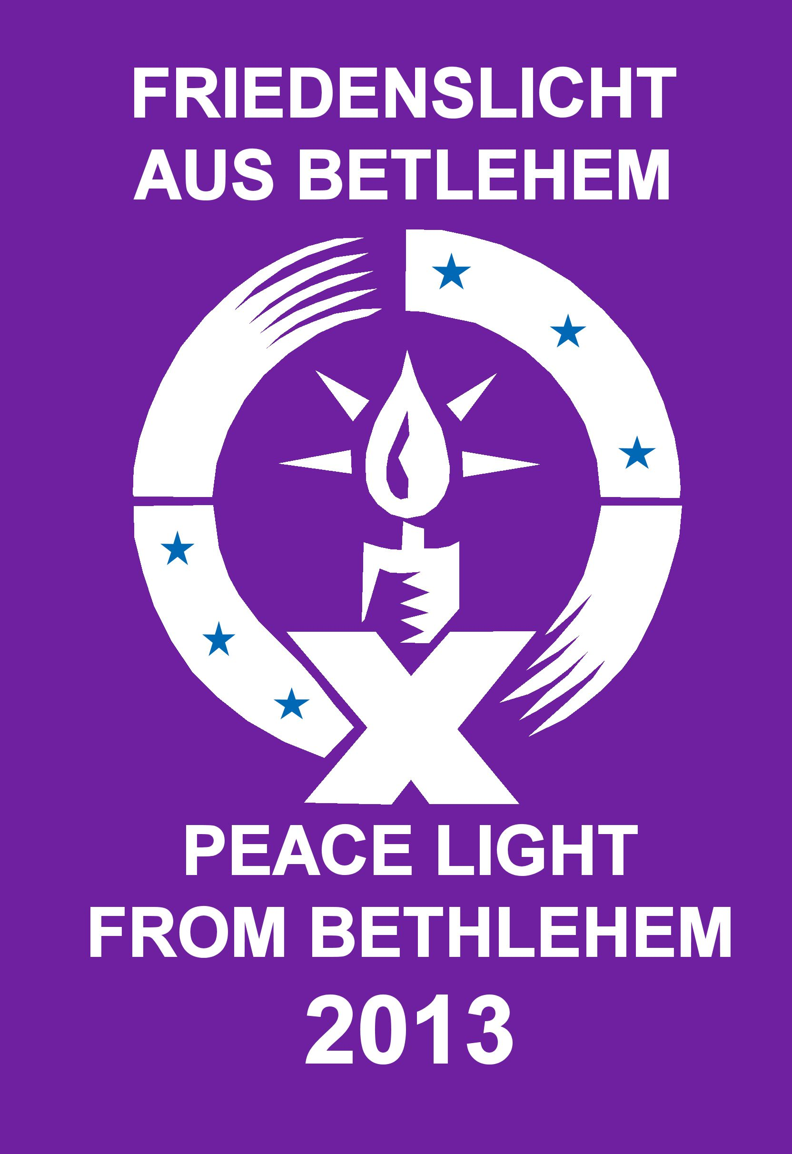

16th Anniversary of the Peace Light in North America
Ceremony of Reception and Passing of Peace
Saturday, November 25, 2017, 3:00 PM
Our Lady of the Skies Catholic Chapel
JFK International Airport, Queens N.Y.
Terminal Four, Upper Level

PROGRAM

Gathering of Participants at Chapel starts around 2:00 PM

Distribution of Programs

Signing of Guest Books

Terminal Four Short Term Parking Ticket Validation at Chapel Office
(Small donation to the Chapel is encouraged in exchange for the validation of your short term parking ticket)

Placement of Lanterns on Chapel Altar

Ceremony will commence soon after the arrival of the Peace Light flame escorts on Austria Airline flight OS/87 from Vienna, Austria

Welcome
Rev. Chris Piasta, Catholic Chaplain, JFK International Airport

Opening Prayer
Chaplain
Catholic Committee on Scouting - Diocese of Brooklyn/ Queens

Opening Hymn – Prayer of St. Francis

Make me a channel of your peace. Where there is hatred let me bring your love. Where there is injury, your pardon Lord, and where’s doubt true faith in you.
Make me a channel of your peace. Where there is despair in life, let me bring hope. Where there is darkness – only light, and where there’s sadness ever – joy.

Oh Master grant that I may never seek, so much to be consoled as to
Console, to be understood, as to understand, to be loved, as to love, with all my soul.

Make me a channel of your peace; it is in pardoning that we are pardoned, in giving of ourselves that we receive, and in dying that we’re born to eternal life

Passing of the Peace Light Flame
All say:

“We gladly receive this light as a sign of our willingness
to be channels of peace, by our words and actions”.

[Candles “infused with the Peace Light flame” can be extinguished, and taken by participants to be presented to others or sent with a message over distances where a live Peace light flame cannot be safely transported, such as to deployed military members, etc.]

Reading from Isaiah
Scout

The people who walked in darkness have seen a great light. Those who dwelt in a land of deep darkness, on them has light shined. Thou hast multiplied the Nation; thou has increased its joy. They rejoice before thee as with joy at the harvest, as men when they divide the spoil. For unto us a child is born, to us a son is given, and the government will be upon his shoulder, and his name will be called “Wonderful Counselor, Mighty God, Everlasting Father, and Prince of Peace”. Of the increase of his government and peace there will be no end. Upon the throne of David, and over this kingdom, to establish it, and to uphold it with justice and with righteousness from this time forth and for evermore. The zeal of the Lord of hosts will do this.

REFLECTION ON THE READING AND PEACE LIGHT
Chaplain

Hymn - Let There Be Peace on Earth

Let there be peace on earth, and let begin with me.
Let there be peace on earth, the peace that meant to be. With God as our Father, we are family. Let us walk with each other in perfect harmony.
Let peace begin with me; let this be the moment now.
With every step I take, let this be my solemn vow:
To take each moment and live each moment in peace eternally.
Let there be peace on earth and let it begin with me.

Messengers of Peace
Paul D. Stanton

Peace Light Hymn

We Sing, (to the tune Edelweiss), the a Hymn written by the Austrian Scouts and Guides and as a thank you salute to them, and our scouting friends in the Transatlantic Council who will represent the BSA and GSA at the 2017 Peace Light distribution ceremony in Vienna, Austria

Come, O Lord, be with us
Fill us with joy and thanksgiving
May our hearts flow with peace,
come with Your love, surround us.
Friendship and peace, may they bloom and grow,
Bloom and grow forever.
Bless us now, bless our friends.
Bless all mankind forever

Father God up above
All your blessings surround us
love and care, everywhere
In the world all around us.
Grant that our services may be of use
Bless the Peace Light endeavor
Father God, up above
Bless us now and forever

LORDS PRAYER

Closing Prayer
Chaplain

May the peace of God and the love of mankind guide us throughout this special day and let out light so shine that men will see our good works and glorify God.

We are met in the spirit of thanksgiving and joy, for the Peace Light from Bethlehem is in our presence.

May the peace symbolized by this Light touch each person who carries it and each who receives it. It is through this sharing of the light of Christ that we pray for the peace of God be spread to all, this Christmas time and always.

The Grace
(Said by All)

The Grace of One we call Lord
The Love of God
The Fellowship of his kindly spirit
Be with us all evermore

History of the Peace Light

The Peace Light, symbolic of the Light of Christ especially evident at Christmas, is meant to promote peace, harmony and unity among the people of the world regardless of race, ethnicity or creed. For several decades, the International Scouting movement, Boy and Girl Scouts, have actively promoted global peace and harmony through the distribution of the Peace Light.

Now in its 31th year, the Peace Light from Bethlehem campaign was originally organized by the Austrian Broadcasting Company - ORF (Linz) - and was part of a large charitable relief mission - Light into Darkness, for children in need in Austria and abroad. Since 1986, there has been a great deal of cooperation between Scouts and Guides in many countries which has allowed the light to travel throughout Europe, such that the light is passed on 30 European Countries and for the past 16 years to America, Canada and Mexico.

Each year, safety permitting, a child from Upper Austria travels as a pilgrim to obtain the flame from the grotto at the Church of the Nativity in Bethlehem where Jesus was believed to be born. This year the flame was transferred only one day ago. The light was then flown to Austria where it began its flight to New York 10 hours ago. Later this year the light will be distributed in Vienna, Austria at a Service of Dedication to delegations from across Europe who take it back, with a message of Peace, to their own countries for use at ecumenical services throughout the Continent. Scouts and Guides then take the light on to other churches, hospitals, old people homes, prisons, and places of public, cultural and political importance - to anybody that appreciates the significance of the “gift”.

In past years the light has been presented to Pope Francis, Pope John Paul II and Pope Benedict XVI, Mikhail Gorbatshow, former King Hussain of Jordan, EU President Romano Prodi and other member of the European parliament, the UN Troops in Kosovo, Military Chaplains, the Rector of St. Patrick’s Cathedral in NY, and to the families who lost children at Sandy Hook, CT. At St. Paul’s Chapel, on Broadway, in NYC a Peace Light Lantern and flame has been displayed on the Church Altar, as a tribute to the Church’s role in providing spiritual support and a place for quiet reflection and peace for Ground Zero rescue and recovery workers following the tragic events of 9/11. In past years volunteers presented the Peace Light to Military Chaplains, representing soldiers from Fort Hamilton, Brooklyn, Fort Bragg NC, the Pentagon, 29 Palms, Picatinny Arsenal, and other duty stations. The Transatlantic Council of the BSA annually distributes the Peace Light widely on the European Continent to American families and military members working abroad.

“The Light of Friendship & Peace” was first introduced to the United States in the year 2000. It was flown over from Oslo, Norway with a brief stopover in London, England before landing in Bartlesville, Oklahoma the headquarters of Phillips Petroleum Co., the sponsors of the flight. The light quickly spread to six states in the heartland of America.

The Catholic Committee on Scouting of the Diocese of Brooklyn and Queens, again has the privilege of welcoming the Light to the United States, at the request of Austrian Scouting and in conjunction with the International Division of the Boy Scouts of America. And the WSOM Messengers of Peace Programs. The Peace Light has made its long journey from the Grotto of the Nativity in the Town of Bethlehem, City of Jerusalem, in Israel, to Vienna, Austria and finally safely across the Atlantic Ocean to NYC. North America.

Special thanks to our friends in Austrian Scouting and the professionals of Austrian Airlines for making this cross Atlantic Ocean Peace light Distribution possible. Following the reception at Our Lady of the Skies Chapel the Peace Light will be distributed by hundreds of Girl and Boy Scouts at various locations nationwide in order to promote peace and harmony. If there is to be World Peace it must begin at a personal level. Please note that while Scouts send the peace Light and receive it for the people of the United States, the symbol, when presented as a gift, can benefit and uplift people from all walks of life, ages, religions, cultures, etc. Our Committee’s goal is to see the Light, distributed to as many possible groups, organizations, and individuals as possible during Advent, Christmas and by New Year’s Day 2018.

Many Churches use the Peacelight in Advent worship services, parish tree lighting events, and many even maintain the Peacelight year round using the flame to ignite their Sanctuary Lights, Baptismal Candles, and Votive Lamps, School and Rectory hot water heater and stove pilot lights. The Plast, Lithuanian, Polish and Ukrainian Scouting Groups in the USA and Canada have also widely supported the Peace Light distribution program.

As residents of the World Capital City of New York we have a special interest in seeing that the Peace Light’s message will rapidly spread like branches on a tree across the North American Continent.

Joe Reding of Boy Scout Troop 113, in Bayport Minnesota, faithfully created and maintained a Peace Light distribution and tracking tool on his Web Site. “www.peacelight.org”. He tracked and mapped the movements of Peace Light by zip codes across the USA, Canada, and Mexico. Joe later also developed a Facebook “Peace Light – North America” web site where distribution plans and route maps are shared. Please visit, join and share your distribution plans and event information on our Facebook group.

Worldwide, communities seeking international friendship, understanding, respect mercy, peace & kindness are a special concern of all Boy & Girl Scouts here and abroad. According to the ideals of Scouting, Scouts pledge to encourage everyone, all nations and peoples, through personal contacts to actively create Peace and fear-free living in their environment by being tolerant towards different ethnic, cultural or religious groups.

You are invited to send information about your 2017-2018 Peace Light Distributions including photos and links to published articles about your Peace Light events to pdstanton@aol.com, International Representative GNYC BSA, and Chairman, Diocese of Brooklyn Catholic Committee on Scouting. Photos of today’s ceremony will be posted at “http://www.ccosbq.org”

You will find links to the UK and other World Scouting Peace Light contacts at GAZ’s website. http://www.peacelight.org.uk/ This website includes information about safe handling of the Peace light flame and how it is distributed throughout the European Continent and History of the Peace Light “movement”.

Thanks

To Fr. Chris Piasta, JFK Catholic Chaplain, for hosting today’s event at JFK’s beautiful Our Lady of the Sky’s Chapel and to our Diocese of Brooklyn Scouting Chaplains James Noble and Vincent Lino for serving as the emcees and lead Celebrants for our 2017 Peace Light arrival and distribution event.

To the Police Officers from the Port Authority of NY/ NJ who together with US Customs and Border Patrol and Department Homeland Security Officers who helped facilitate the timely Arrival of the Peace light here at JFK. A salute to the JFK Customs & Border Patrol Law Enforcement Explorer Post members who served as uniformed escorts at today’s event.

To the Members of the Diocese of Brooklyn Committee on Scouting for ongoing planning and coordination of the Annual Peace Light Arrival Event
.
To all “Messengers of Peace” who have traveled from near and far to be here today to receive the Peace Light flame originating at the Grotto of the Nativity, Town of Bethlehem, City of Jerusalem, Israel

Best wishes from Most Rev. Nicholas Di Marzio, Bishop of the Diocese of Brooklyn, to all for a safe and joyful Advent and Peace Light experience.



